Regional VHF / UHF Ham Template
Emergency Response Frequencies
YCARES May 2017

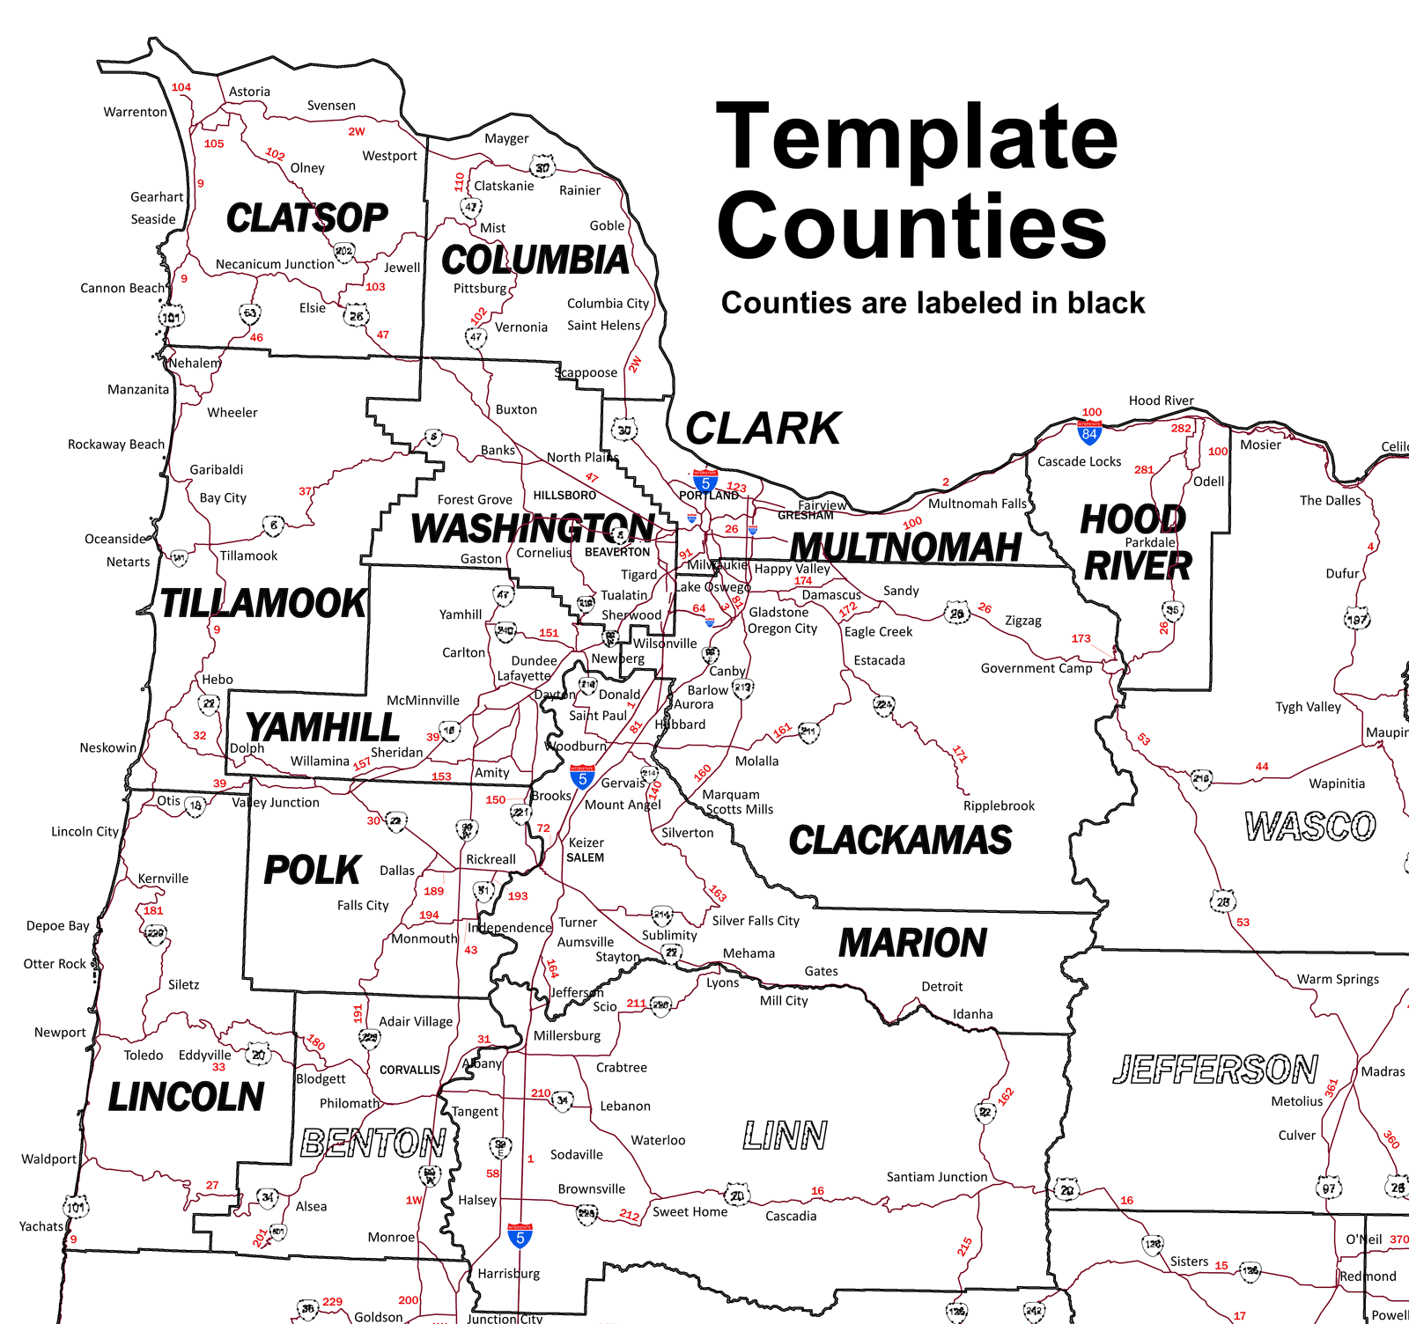

YCARES May 2017

2017 Ham Regional Template
YCARES May 2017
YAMHILL COUNTY FREQUENCIES
Channel | Alias | Freq | Offset | Tone | Description
1 | YMHL 1 | 441.800 | +5 | 114.8 | Yamhill Primary Repeater W7YAM
2 | YMHL 2 | 146.640 | -0.6 | 100.0 | Yamhill Secondary Repeater W7RXJ
3 | YMHL 3 | 442.550 | +5 | 100.0 | Yamhill Tertiary Repeater K0INK
4 | YMHL 4 | 146.400 | -- | -- | Yamhill Primary Simplex
5 | YMHL 5 | 147.520 | -- | -- | Yamhill Secondary Simplex
6 | YMHL 6 | 441.575 | -- | -- | Yamhill UHF Primary Simplex
7 | YMHL 7 | 441.600 | -- | -- | Yamhill UHF Secondary Simplex
8 | YAM-10 | 144.920 | -- | -- | RMS Yamhill Gateway W7YAM-10 Eola Hill
9 | YAM-11 | 144.960 | -- | -- | RMS Yamhill Gateway W7YAM-11 EOC
10 | YAM-12 | 441.050 | -- | -- | RMS Yamhill Gateway W7YAM-12 Eola Hill
11 | D1 1 | 147.320 | +0.6 | 100.0 | D-1 Primary Net Repeater
12 | HRT 1 | 145.230 | -0.6 | -- | HEART Net Primary Repeater
13 | TLMK 1 | 147.220 | +0.6 | 100.0 | Tillamook Primary Repeater
14 | POLK 1 | 145.330 | -0.6 | 186.2 | Polk Primary Repeater
15 | MARN 1 | 145.290 | -0.6 | -- | Marion Primary Repeater
16 | WC 1 | 146.900 | -0.6 | 127.3 | Washington Primary Repeater
17 | LINC4 | 146.780 | -0.6 | 156.7 | Lincoln Alternate Repeater - Mary's Peak
18 | W7GRT | 146.660 | -0.6 | 136.5 | Grand Ronde Tribe 2m Repeater - 20 watts
19 | W7GRT | 442.825 | +5 | 123.0 | Grand Ronde Tribe 440 Repeater - 100 watts
20
CLACKAMAS COUNTY
Channel | Alias | Freq | Offset | Tone | Description
21 | CLAC 1 | 147.120 | 0.6 | 100.0 | Clackamas Primary Repeater
22 | CLAC 2 | 147.140 | 0.6 | 107.2 | Clackamas Secondary Repeater
23 | CLAC 3 | 146.415 | -- | -- | Clackamas Primary Simplex
24 | CLAC 4 | 146.960 | -0.6 | 127.3 | Clackamas Tertiary Repeater (W7OTV)
25 | CLAC 5 | 146.920 | -0.6 | 107.2 | Clackamas South County ARES Repeater
26 | CLAC 6 | 146.580 | -- | -- | Clackamas South County ARES Simplex
27 | CLAC 7 | 442.075 | +5 | 103.5 | Oregon City ARES Repeater
28 | CLAC 8 | 146.560 | -- | -- | Oregon City ARES Simplex
29 | CLAC 9 | 146.500 | -- | -- | Lake Oswego ARES Simplex
30 | CLAC 10 | 145.770 | -- | -- | Packet Clackamas Co. EOC (kd7zdo@w7szs.or.us.noam)
31 | CLAC 11 | 145.570 | -- | -- | RMS packet gateway KD7ZDO-10
32 | CLAC 12 | 147.500 | -- | -- | Clackamas North County ARES Simplex
33 | CLAC 13 | 147.510 | -- | -- | Clackamas West County ARES Simplex

CLARK COUNTY
Channel | Alias | Freq | Offset | Tone | Description
34 | CLRK01 | 147.240 | +0.6 | 94.8 | Clark Secondary Repeater - W7AIA
35 | CLRK02 | 443.925 | +5 | 94.8 | Clark Primary Repeater - W7AIA
36 | CLRK03 | 443.125 | +5 | 94.8 | Clark Tertiary Repeater - W7AIA
37 | CLRK04 | 147.240 | -- | -- | Clark No-Repeater Simplex - NCS (Talk-Around Secondary Rptr.)
38 | CLRK05 | 147.530 | -- | 94.8 | Clark Common Simplex
39
40 | CLRK26 | 442.375 | +5 | 123.0 | Clark Traffic Repeater - AB7F
41 | CLRK27 | 443.675 | +5 | 107.2 | Clark Traffic Repeater - KE7FUW
42 | CLRK28 | 443.975 | +5 | 123.0 | Clark Traffic Repeater - KB7APU
43
44 | CLRK45 | 223.700 | -- | -- | RMS K7YFJ-10, K7GJT-10 (1200Bd)
45 | CLRK46 | 144.990 | -- | -- | Packet BBS K7CLL-8 (1200Bd)
46 | CLRK47 | 441.060 | -- | -- | Packet BBS K7CLL-8 (9600Bd)
47 | CLRK48 | 144.920 | -- | -- | RMS K7YFJ-10, KA7CTT-10 (1200Bd)
48 | CLRK49 | 441.525 | -- | -- | RMS K7YFJ-10, K7GJT-10 (9600Bd)
49 | CLRK50 | 144.940 | -- | -- | RMS K7GJT-10, KB7APU-10 (1200Bd)
COLUMBIA COUNTY
Channel | Alias | Freq | Offset | Tone | Description
50 | COL 1 | 146.880 | -0.6 | 114.8 | Columbia Primary Repeater
51 | COL 2 | 444.625 | +5 | 107.2 | Columbia Secondary Repeater
52 | COL 3 | 146.500 | -- | -- | Columbia Primary Simplex
53 | COL 4 | 147.470 | -- | -- | Columbia Secondary Simplex
54 | COL 5 | 146.440 | -- | -- | Columbia Tactical Simplex
55 | COL 6 | 146.680 | -0.6 | 114.8 | Columbia South County
56 | COL 7 | 145.350 | -0.6 | 114.8 | Clatskanie
57 | COL 8 | 145.270 | -0.6 | 107.2 | Timber Repeater (Clatsop - Tillamook Co. D1 link)
58 | COL 9
59 | COL 10
60 | COL 11 | 145.510 | -- | -- | Packet N7EI-1
61 | COL 12 | 144.920 | -- | -- | RMS N7EI-10
62 | COL 13 | 144.990 | -- | -- | Hocksen Packet Node East County N7EI-1

MULTNOMAH COUNTY
Channel | Alias | Freq | Offset | Tone | Description
63 | MC 1 | 146.840 | -0.6 | -- | Multnomah Primary Repeater
64 | MC 2 | 147.280 | +0.6 | 167.9 | Multnomah Secondary Repeater
65 | MC 3 | 146.940 | -0.6 | -- | Multnomah Tertiary Repeater
66 | MC 4 | 146.480 | -- | -- | Multnomah Primary Simplex
67 | MC 5 | 146.460 | -- | -- | Multnomah Secondary Simplex
68 | MC 6 | 147.040 | +0.6 | 100.0 | Multnomah Delta Repeater
69 | MC 7 | 147.560 | -- | -- | Gresham Simplex
70 | MC 8 | 147.580 | -- | -- | NET-Tac 1 (Portland Bureau of Em. Mgmt.)
71 | MC 9 | 147.540 | -- | -- | NET-Tac 2 (Portland Bureau of Em. Mgmt.)
72 | MC 10 | 145.070 | -- | -- | RMS K7MCE-10 / Packet K7EOC-1
73 | MC 11 | 146.840 | -- | -- | Talk-Around Multnomah Primary Repeater
74 | MC 12 | 147.280 | -- | -- | Talk-Around Multnomah Secondary Repeater
75 | MC 13 | 146.940 | -- | -- | Talk-Around Multnomah Tertiary Repeater
76 | MC 14 | 147.040 | -- | -- | Talk-Around Multnomah Delta Repeater
WASHINGTON COUNTY
Channel | Alias | Freq | Offset | Tone | Description
77 | WC 1 | 146.900 | -0.6 | 127.3 | Washington Primary Repeater
78 | WC 2 | 147.360 | +0.6 | 107.2 | Washington Secondary Repeater
79 | WC 3 | 440.350 | +5 | 127.3 | Washington Tertiary Repeater
80 | WC 4 | 147.400 | -- | -- | Washington Primary Simplex
81 | WC 5 | 146.440 | -- | -- | Washington Secondary Simplex
82 | WC 6 | 147.440 | -- | -- | Land Use Transportation (LUT) Simplex
83 | WC 7 | 147.500 | -- | -- | TVF&R Simplex
84 | WC 8 | 147.560 | -- | -- | DStar-DRats 1200 Bd / WCCCA Simplex
85 | WC 9 | 440.550 | +5 | -- | DStar Repeater N7QQU B
86 | WC 10 | 432.200 | -- | -- | Washington UHF Primary Simplex
87 | WC 11 | 145.550 | -- | -- | Relay Post Office KC7PMU-10 (1200 Bd)
88 | WC 12 | 144.910 | -- | -- | KD7REX-1 BBS WCCCA
89 | WC 13 | 144.980 | -- | -- | RMS WC7EOC-10 Washington Co. EOC
90 | WC 14 |  | -- | --
91 | WC 15 | 145.050 | -- | -- | RMS K7TRP-10, N7OGM-10 (1200 Bd)
92 | WC 16 | 145.580 | -- | -- | Packet Hospital Direct (1200 Bd)
93 | WC 17 | 147.540 | -- | -- | DStar, SSTV Simplex
94 | WC 18 | 145.040 | -- | -- | RMS KX7YT-10 (1200 Bd)
95 | WC 19 | 441.075 | -- | -- | RMS K7CPU-10 Intel (1200 Bd)
96 | WC 20 | 440.175 | + 5 | 110.9 | Tigard CERT Repeater

OTHER AGENCIES
Channel | Alias | Freq | Offset | Tone | Description
97 | D1 1 | 147.320 | +0.6 | 100.0 | D-1 Primary Net Repeater
98 | D1 2 | 146.840 | -0.6 | -- | D-1 Secondary & Multnomah Co. ARES Primary Repeater
99 | OEM 1 | 145.330 | -0.6 | 186.2 | Oregon Emergency Management (Salem)
100 | RED C1 | 146.980 | -0.6 | 123.0 | Red Cross Repeater (Portland)
101 | RED CR | 147.420 | -- | -- | Red Cross Simplex
102 | HRT 1 | 145.230 | -0.6 | -- | HEART Net Primary Repeater
103 | HRT 2 | 442.700 | +5 | 100.0 | HEART Net Secondary Repeater
104 | HRTSIM | 146.600 | -- | -- | HEART Simplex
105 | BCRT 1 | 147.380 | +0.6 | 100.0 | Beaverton CERT Primary Repeater
106 | BCRT 2 | 147.480 | -- | -- | Beaverton CERT Primary Simplex
107 | INTEL1 | 145.520 | -- | -- | Intel Emergency Amateur Radio Service (IEARS)
108 | YMHL8 | 144.960 | -- | -- | Yamhill County RMS W7YAM-11 EOC
109 | TLMK 1 | 147.220 | +0.6 | 100.0 | Tillamook Primary Repeater
110 | TLMK 2 | 147.160 | +0.6 | 118.8 | Tillamook Central Repeater
111 | TLMK 3 | 440.175 | +5 | 100.0 | Tillamook North Repeater
112 | TLMK 4 | 441.250 | +5 | 118.8 | Tillamook South Repeater
113 | TLMK 5 | 444.425 | +5 | 107.2 | Tillamook Nehalem Bay Repeater
114 | TLMK 6 | 146.560 | -- | -- | Tillamook North Simplex
115 | TLMK 7 | 147.420 | -- | -- | Tillamook Central Simplex
116 | TLMK 8 | 147.500 | -- | -- | Tillamook South Simplex
117 | TLMK 9 | 144.950 | -- | -- | RMS KB7EOC-10 Tillamook Co. EOC (1200 Bd)
118 | CLAT 1 | 145.450 | -0.6 | 118.8 | Clatsop Primary Repeater
119 | CLAT 2 | 146.760 | -0.6 | 118.8 | Clatsop Secondary Repeater
120 | CLAT 3 | 145.490 | -0.6 | 118.8 | Clatsop Tertiary Repeater
121 | CLAT 4 | 146.580 | -- | -- | Clatsop North Simplex
122 | CLAT 5 | 147.580 | -- | -- | Clatsop South Simplex
123 | CLAT 6 | 146.400 | -- | -- | Clatsop Seaside Simplex
124 | CLAT 7 | 144.960 | -- | -- | RMS N7AST-10 Clatsop EOC (1200 Bd) Satellite
125 | CLAT 8 | 144.960 | -- | -- | RMS KD7IBA-10 Warrenton (1200 Bd) Satellite
126 | CLAT 9 | 144.960 | -- | -- | RMS WA7VE-10 Seaside (1200Bd) Satellite
127 | LINC 1 | 145.370 | -0.6 | 167.9 | Lincoln Primary Repeater
128 | LINC 2 | 147.040 | +0.6 | 100.0 | Lincoln Secondary Repeater
129 | LINC 3 | 147.000 | +0.6 | 136.5 | Lincoln Tertiary Repeater
130 | LINC 4 | 146.780 | -0.6 | 156.7 | Lincoln Alternate Repeater - Mary's Peak
131 | LINC 5 | 146.580 | -- | -- | Lincoln Primary Simplex
132 | LINC 6 | 145.090 | -- | -- | RMS Gateway W7LCS-10 Newport / W7GC-10 Lincoln City
133 | LINC 7 | 144.950 | -- | -- | Alternate RMS Gateway Mt. Hebo W7GC-11
134 | LINC 8

OTHER AGENCIES Cont.
Channel | Alias | Freq | Offset | Tone | Description
135 | YMHL 1 | 441.800 | +5 | 114.8 | Yamhill Primary Repeater - W7YAM
136 | YMHL 2 | 146.640 | -0.6 | 100.0 | Yamhill Secondary Repeater - W7RXJ
137 | YMHL 3 | 442.550 | +5 | 100.0 | Yamhill Tertiary Repeater - K0INK
138 | YMHL 4 | 146.400 | -- | -- | Yamhill Primary Simplex
139 | YMHL 5 | 147.520 | -- | -- | Yamhill Secondary Simplex
140 | YMHL 6 | 441.050 | -- | -- | RMS Yamhill Gateway W7YAM-12 Eola Hill
141 | YMHL 7 | 144.920 | -- | -- | RMS Yamhill Gateway W7YAM-10 Eola Hill
142 | POLK 1 | 145.330 | -0.6 | 186.2 | Polk Primary Repeater
143 | POLK 2 | 147.020 | +0.6 | 186.2 | Polk Secondary Repeater
144 | POLK 3 | 145.350 | -0.6 | 186.2 | Polk Tertiary Repeater
145 | POLK 4 | 146.500 | -- | -- | Polk Primary Simplex
146 | POLK 5 | 144.970 | -- | -- | RMS Polk Gateway W7PLK-10 w7plk@winlink.org
147 | POLK 6
148 | MARN 1 | 145.290 | -0.6 | -- | Marion Primary Repeater
149 | MARN 2 | 145.190 | -0.6 | 100.0 | Marion Secondary Repeater
150 | MARN 3 | 146.480 | -- | -- | Marion Primary Simplex
151 | MARN 4 | 145.070 | -- | -- | RMS Marion Gateway K7MAR-10 k7mar@winlink.org
152 | MARN 5 | 431.200 | -- | -- | UHF Simplex
153 | HOOD 1 | 145.150 | -0.6 | 94.8 | Hood River Primary Repeater
154 | HOOD 2 | 444.900 | +5 | 100.0 | Hood River Secondary Repeater
155 | HOOD 3 | 147.100 | +0.6 | 100.0 | Hood River Tertiary Repeater
156 | HOOD 4 | 147.500 | -- | -- | Hood River Primary Simplex
157 | HOOD 5 | 146.460 | -- | -- | Hood River Secondary Simplex
158 | HOOD 6 | 445.500 | -- | -- | Hood River UHF Simplex
159 | HOOD 7 | 145.750 | -- | -- | RMS Hood River KA7HRC-10 (1200 Bd)
160 | HOOD 8 | 440.750 | -- | -- | RMS Hood River KA7HRC-10 (1200 Bd)
NOTES
SIMPLEX CHANNELS
Channel |  | Alias |  | Freq |  | Offset |  | Tone |  | Description
161 |  | SMPX01 |  | 146.400 |  | -- |  | -- |  | Seaside Simplex / Hood River Secondary
162 |  | SMPX02 |  | 146.420 |  | -- |  | -- |  | Clark County Eyewarn [note: 146.415 is Clackamas primary]
163 |  | SMPX03 |  | 146.440 |  | -- |  | -- |  | Washington County Secondary / Columbia Tactical
164 |  | SMPX04 |  | 146.460 |  | -- |  | -- |  | OR ARES statewide simplex / Multnomah Secondary
165 |  | SMPX05 |  | 146.480 |  | -- |  | -- |  | Multnomah Primary / Marion Primary
166 |  | SMPX06 |  | 146.500 |  | -- |  | -- |  | Polk Primary / Columbia Primary
167 |  | SMPX07 |  | 146.520 |  | -- |  | -- |  | National VHF Simplex Calling Frequency
168 |  | SMPX08 |  | 146.540 |  | -- |  | -- |  | Clackamas South Primary
169 |  | SMPX09 |  | 146.560 |  | -- |  | -- |  | Oregon City ARES Primary
170 |  | SMPX10 |  | 146.580 |  | -- |  | -- |  | Lincoln Primary / Clatsop N. / Clackamas S. / Clark (pl 94.8)
171 |  | SMPX11 |  | 146.600 |  | -- |  | -- |  | HEART
172 |  | SMPX12 |  | 147.400 |  | -- |  | -- |  | Washington County Primary
173 |  | SMPX13 |  | 147.420 |  | -- |  | -- |  | Tillamook County Central / Red Cross Primary
174 |  | SMPX14 |  | 147.440 |  | -- |  | -- |  | Washington County Land Use & Transportation Simplex Traffic
175 |  | SMPX15 |  | 147.460 |  | -- |  | -- |  | Yamhill Primary / Hood River Secondary
176 |  | SMPX16 |  | 147.480 |  | -- |  | -- |  | Beaverton CERT Primary
177 |  | SMPX17 |  | 147.500 |  | -- |  | -- |  | Washington Co. TVF&R / Tillamook Co. South / Hood R. Primary
178 |  | SMPX18 |  | 147.520 |  | -- |  | -- |  | Intel Emergency Am. Radio Service / Yamhill Secondary
179 |  | SMPX19 |  | 147.540 |  | -- |  | -- |  | PBEM NET-Tac 2 / Washington Co. SSTV Simplex Voice/Data
180 |  | SMPX20 |  | 147.560 |  | -- |  | -- |  | WashCo. WCCCA Simplex / DStar/DRats 1200 Bd./ Gresham
181 |  | SMPX21 |  | 147.580 |  | -- |  | -- |  | Clatsop County South Simplex / PBEM NET-Tac 1
UHF SIMPLEX
182 |  | SMPX22 |  | 431.025 |  | -- |  | --
183 |  | SMPX23 |  | 431.050 |  | -- |  | --
184 |  | SMPX24 |  | 431.075 |  | -- |  | --
185 |  | SMPX25 |  | 431.100 |  | -- |  | -- |  | Hillsboro CERT Simplex 1
186 |  | SMPX26 |  | 431.125 |  | -- |  | --
187 |  | SMPX27 |  | 431.150 |  | -- |  | --
188 |  | SMPX28 |  | 431.175 |  | -- |  | --
189 |  | SMPX29 |  | 431.200 |  | -- |  | -- |  | Hillsboro CERT Simplex 2 / Marion Co. UHF Simplex
190 |  | SMPX30 |  | 431.225 |  | -- |  | --
191 |  | SMPX31 |  | 431.250 |  | -- |  | --
192 |  | SMPX32 |  | 431.275 |  | -- |  | --
193 |  | SMPX33 |  | 431.300 |  | -- |  | -- |  | Hillsboro CERT Simplex 3
194 |  | SMPX34 |  | 432.125 |  | -- |  | --
195 |  | SMPX35 |  | 432.150 |  | -- |  | --
196 |  | SMPX36 |  | 432.175 |  | -- |  | --
197 |  | SMPX37 |  | 432.200 |  | -- |  | -- |  | Washington Co. Primary UHF Simplex
198 |  | SMPX38 |  | 432.225 |  | -- |  | --
199 |  | NUCALL |  | 446.000 |  | -- |  | -- |  | National UHF Simplex Calling Frequency
 | 201 |  | X-Band1 |  | 446.435 |  | -- |  | -- |  | Crossband Repeat 1
 | 202 |  | X-Band2 |  | 446.450 |  | -- |  | -- |  | Crossband Repeat 2
 | 203 |  | X-Band3 |  | 446.475 |  | -- |  | -- |  | Crossband Repeat 3

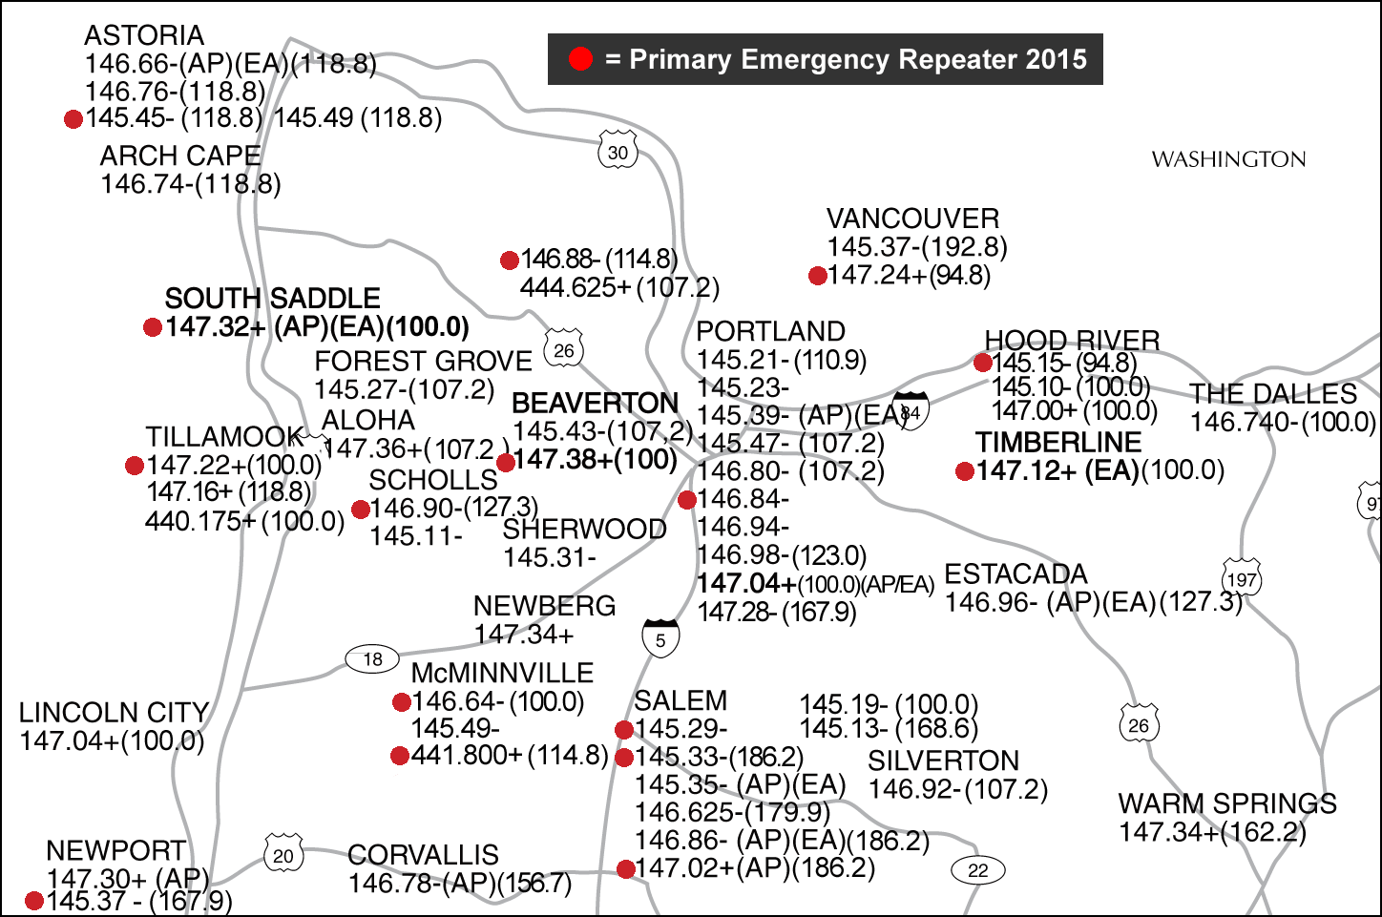

HF Frequencies MHz
1.9780 LSB | Oregon State-Wide ARES/RACES Net (Night secondary)
3.5795 USB | Oregon ARES PSK31 Net (Friday 8 PM)
3.5690 CW | Oregon NTS CW Net (Daily 6:30 & 10 PM)
3.9200 LSB | Beaver State Net (Daily 5:30 PM)
3.9520 LSB | Western Public Service System Net (Daily 6 PM)
3.9640 LSB | Oregon State-Wide ARES/RACES Net (Night primary 1st Tue 7PM W7OEM)
3.9700 LSB | Noontime Net (Daily 12 – 2 PM)
3.9750 LSB | Washington WARTS Net (Daily 6 PM Daylight S.T. /5 PM Standard Time)
3.9800 LSB | Oregon Emergency Net (Daily 6 & 7 PM)
3.9850 LSB | Washington ARES Net Primary (Mon. 6:30 PM / 5:30 winter; alt. 7.245)
5.346.5 USB | EOC-to-EOC & Oregon Emergency Mgmt. W7OEM (50 w ERP max.)
7.2480 LSB | Oregon State-Wide ARES/RACES Net (Day)
7.2685 LSB | Noontime Net (Daily 12 – 2 PM) [alternate 7.2835]
28.4000 USB | Local Ground Wave SSB



